DESIGN A MOBILE BANKING APPLICATION USING BALSAMIQ DESIGN SOFTWARE

Aim: To design a mobile banking application using balsamiq design software

Procedure:

Step 1: Gather Requirements before designing.

Step 2: Install Balsamiq If you haven't already, download and install Balsamiq on your computer. You can choose between the desktop version or the web-based version, depending on your preference.

Step 3: Create a New Project Launch Balsamiq and create a new project for mobile banking app. Choose the appropriate screen size for mobile devices.

Step 4: Start Wireframing, begin creating wireframes for each screen or feature of your mobile banking app. Here's a list of screens you might want to design:

1.Login/Register: Create wireframes for the login and registration screens. Include fields for username/email and password, as well as registration fields if applicable.

2.Account Overview: Design a screen that shows the user's account balances, recent transactions, and other relevant account information.

3.Transactions: Create wireframes for the screen where users can view their transaction history and details.

4.Transfers: Design screens for transferring money between accounts, including selecting the source and destination accounts, entering the amount, and confirming the transfer.

5.Bill Payments: If your app supports bill payments, create wireframes for this feature. Include options to select the biller, enter the amount, and confirm the payment.

6.Settings: Design screens where users can manage their profile, security settings, and notification preferences.

7.Help/Support: Create wireframes for the help and support section, including FAQs, contact information, and chat support if applicable.

Step 5: Use Balsamiq Tools Balsamiq provides various tools to create wireframes quickly. Use basic shapes, text elements, buttons, and other UI components to create your screens. Keep the design simple and focused on functionality.

Step 6: Link Screens (Optional) If you want to create a clickable prototype, you can link the screens together in Balsamiq. This allows you to simulate the user flow by adding clickable areas to buttons and links, enabling you to demonstrate how users would navigate through the app.

Step 7: Review and Refine After creating the initial wireframes, review them to ensure they meet the requirements and provide a seamless user experience. Make any necessary adjustments to the layout, content, or interactions.

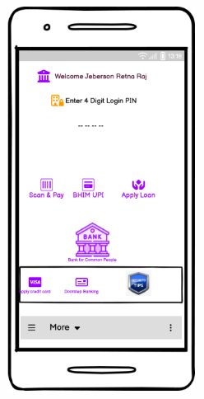 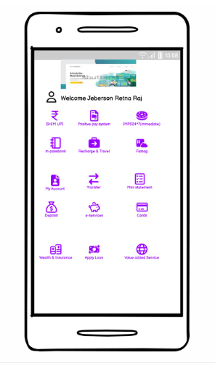

Result: Thus mobile banking application using balsamiq design software has been designed .